**Java Assignment 1**

**Q2. When you compile Java programs on PC, there are two ways. One is the DOS format, and another one is Eclipse IDE. Download both platforms onto your personal PC. Describe step by step process for downloading. Show screenshots to prove both ways. (2 points)**

**Answer:**

Java Installation:

1. Download java from <https://www.oracle.com/java/technologies/downloads/>

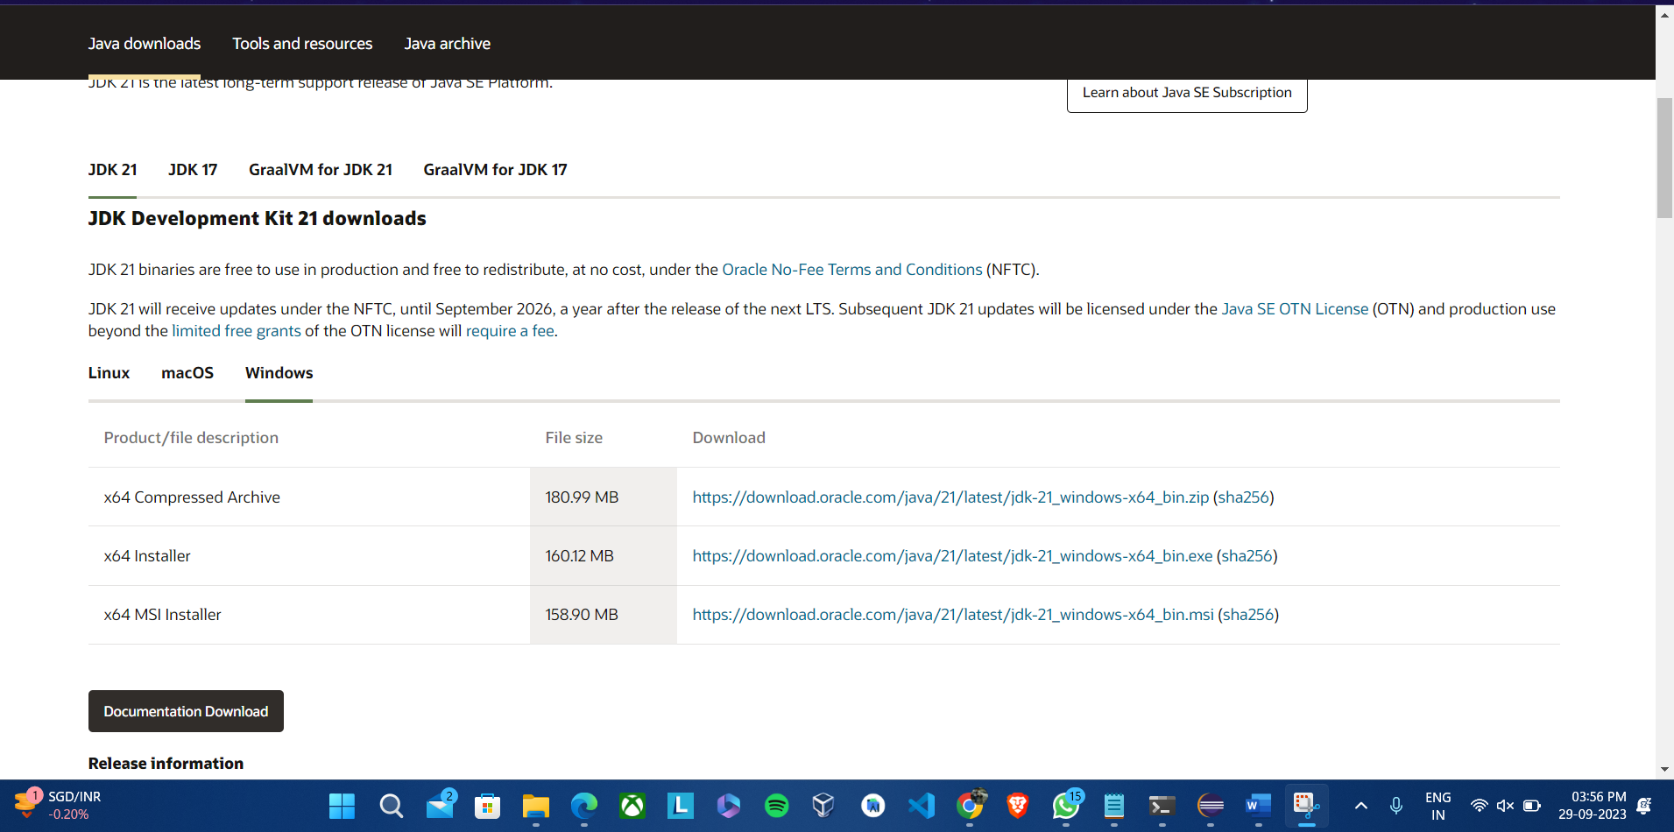

1. Run the installer

1. Open **Command Prompt** and check if java is installed by typing **java --version**

1. Open up a **Notepad** and write a java program. **Save** the file as **ClassName.Java** (HelloWorld.Java, in my case)

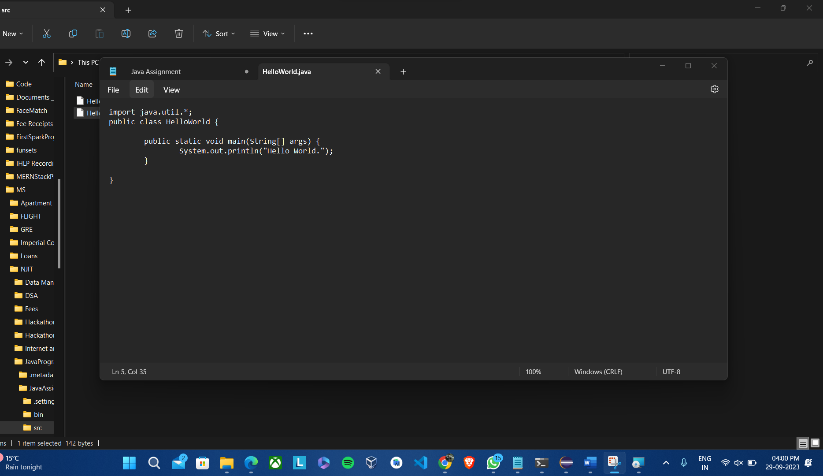

1. Go the path where the HelloWorld.java file is using **cd** command. Then enter **javac HelloWorld.java** to compile your java code. After that, enter **java HelloWorld** to run the java code and see the output on the command line.

Eclipse Installation:

1. Go to <https://www.eclipse.org/downloads/> and **download** the latest version of Eclipse

1. **Run the exe** file and select Eclipse IDE for Java Developers

1. Click next after reviewing the java path location

1. **Create a new Java Project** and select your JDK Version your use the default JRE and click on Finish.

1. Expand the JavaAssignment1 project structure and navigate to the src folder and **create a new java class**.

1. Write code and **save** it.

1. **Click on the run** button on the top tab and the **output will be shown on the console** at the bottom.

**Q3. C.**

**4.30 (Global Warming Facts Quiz) The controversial issue of global warming has been widely publicized by the film "An Inconvenient Truth," featuring former Vice President Al Gore. Mr. Gore and a U.N. network of scientists, the Intergovernmental Panel on Climate Change, shared the 2007 Nobel Peace Prize in recognition of "their efforts to build up and disseminate greater knowledge about man-made climate change." Research both sides of the issue online. Create a five-question multiple-choice quiz on global warming, each question having four possible answers (numbered 1- 4). Be objective and try to fairly represent both sides of the issue. Next, write an application that administers the quiz, calculates the number of correct answers (zero through five) and returns a message to the user. If the user correctly answers five questions, print "Excellent"; if four, print "Very good"; if three or fewer, print "Time to brush up on your knowledge of global warming," and include a list of some of the websites where you found your facts. (1 point)**

**Answer:**

**Quiz** **source**: <https://www.proprofs.com/quiz-school/story.php?title=global-warming-quiz_2>

A short quiz game regarding global warming is provided by this Java program. It collects user input for answers to a series of questions using a **Scanner**. The program defines arrays to store questions, answer options, and the correct answers. The user is then prompted for their selection after **iteratively** going through each question while presenting multiple-choice answers. The user's entry is checked against the right response, and if it matches, the **correctAnswers** counter is increased. Following completion of all questions, the application **closes** **the scanner** and delivers feedback depending on the percentage of accurate responses.

**Source Code:**

import java.util.Scanner;

public class JavaQuiz {

public static void main(String[] args) {

Scanner sc = new Scanner(System.***in***);

int correctAnswers = 0;

// Define arrays to store questions, answer options, and correct answers

String[] questions = {

"What is the primary greenhouse gas responsible for global warming?",

"Increased Global temperatures are caused by what??",

"Which Arctic animal is the most endangered from Global Warming",

"Most of the rubbish your family throws away each day ends up getting",

"Our waterways are polluted by.."

};

String[][] answerOptions = {

{"Oxygen", "Nitrogen", "Carbon dioxide (CO2)", "Hydrogen"},

{"Natural Disasters", "Humans", "Animals", "All of the above"},

{"Sea lions", "Polar Bears", "Walrus", "Narwhals"},

{"Recycled","Burned","Landfilled","Eaten"},

{"Dumping used oil on the ground", "Leaking underground gasoline storage tanks", "Leaking of old landfill", "All of the above"}

};

int[] correctAnswersArray = {2, 1, 3, 2, 3}; // Index of correct answers (0-based)

System.***out***.println("Global Warming Facts Quiz");

System.***out***.println("Answer each question with the number (1-4) corresponding to your choice.");

System.***out***.println();

for (int i = 0; i < questions.length; i++) {

System.***out***.println("\nQuestion " + (i + 1) + ": " + questions[i]);

for (int j = 0; j < answerOptions[i].length; j++) {

System.***out***.println((j + 1) + ". " + answerOptions[i][j]);

}

System.***out***.print("\nEnter one answer from 1-4: ");

int userAnswer = sc.nextInt();

if (userAnswer - 1 == correctAnswersArray[i]) {

correctAnswers++;

}

}

// Provide feedback based on the number of correct answers System.***out***.println("\nYou answered " + correctAnswers + " out of " + questions.length + " questions correctly.");

if (correctAnswers == questions.length) {

System.***out***.println("\nExcellent!");

} else if (correctAnswers >= questions.length - 1) {

System.***out***.println("\nVery good!");

} else {

System.***out***.println("\nTime to brush up on your knowledge of global warming.");

}

sc.close();

}

}

**Explanation:**

1. Import the Scanner class to enable user input handling.

2. Define the JavaQuiz class and its main method, which is the starting point of the program.

3. Create a Scanner object named scanner to read input from the user.

4. Initialize an integer variable correctAnswers to keep track of the number of correct answers

5. Define arrays to store questions, answer options, and the correct answers:

1. questions: An array of strings that holds the quiz questions.
2. answerOptions: A two-dimensional array of strings where each row corresponds to the answer options for a question.
3. correctAnswersArray: An array of integers that holds the index of the correct answer for each question (0-based).

6. Display an introductory message for the quiz

7. Begin a for loop to iterate through the questions. The loop uses i as an index variable to access each question and its associated answer options.

8. Inside the loop:

1. Display the current question along with its multiple-choice answer options using nested loops. The inner loop iterates through the answer options.
2. Prompt the user to enter their answer using System.out.print("\nEnter one answer from 1-4: ").
3. Read the user's input as an integer using scanner.nextInt() and store it in the variable userAnswer.

9. Check if the userAnswer is correct by comparing it to the correct answer index stored in correctAnswersArray. If the user's answer matches the correct index (subtracting 1 because the user's input is 1-4 while the correctAnswersArray is 0-based), increment the correctAnswers counter.

10. After all questions are answered, the program provides feedback to the user based on the number of correct answers. It categorizes the user's performance as "Excellent," "Very good," or "Time to brush up on your knowledge of global warming" based on the number of correct answers.

11. Close the scanner object to release resources when the quiz is complete.

**Output:**

1. Quiz questions with answers in console:

1. When all questions are answered correctly:

1. When 4 questions are answered correctly:

1. When 3 or less questions are answered correctly:

